**Advanced Learning Algorithms**

Neural Networks

Let’s imagine we have a clothes shop, and we want to predict the demand of a certain shirt.

So we will have multiple parameters like price, shipping cost, marketing, and material to predict through it, then these parameters go through small neural networks that it’s output is 0 or 1 (logistic regression) then the output is the probability of being top seller.

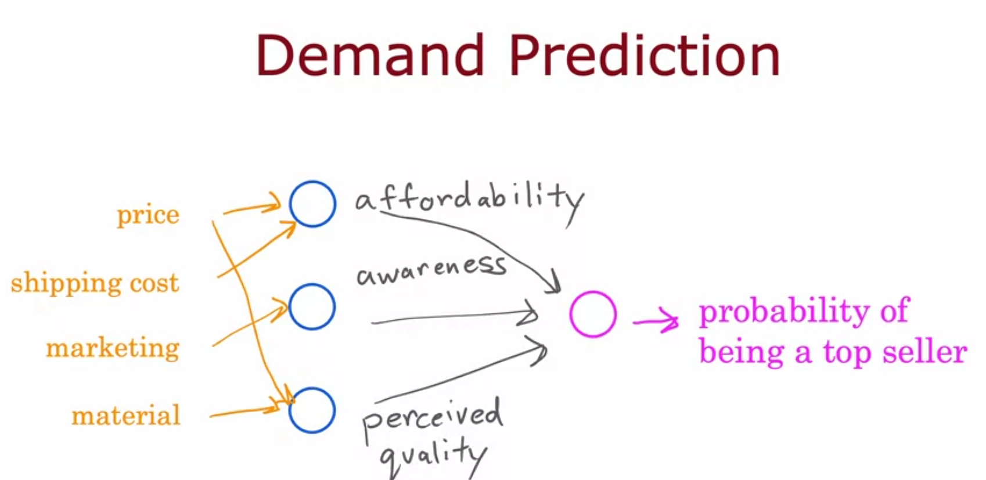

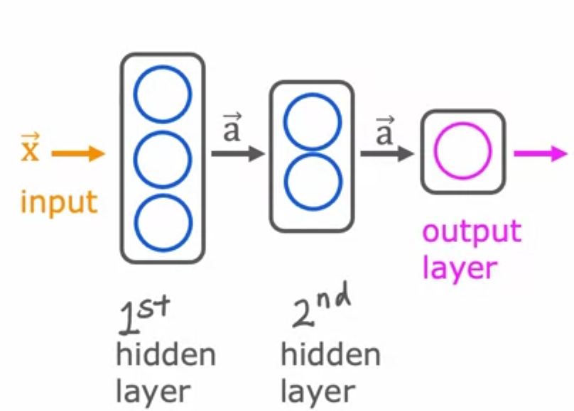

Neural Network consists of input layer, hidden layers, and output layer

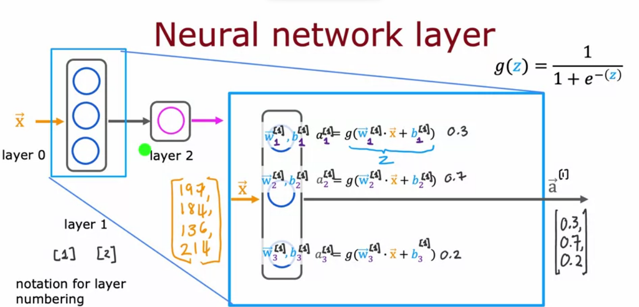

Superscript refers to the index of layer.

e.g. [1] means layer 1

subscript refers to index of neuron of the layer

so w[1]2 layer 1 neuron 2

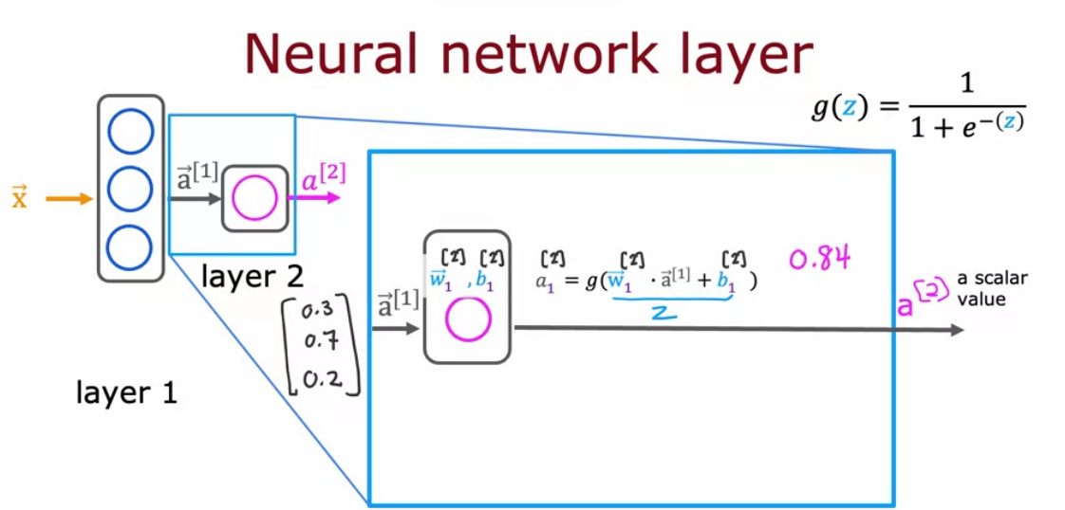

a general equation to get a[l]j

